Top 5 Natural Oils to Boost Your Skin Health
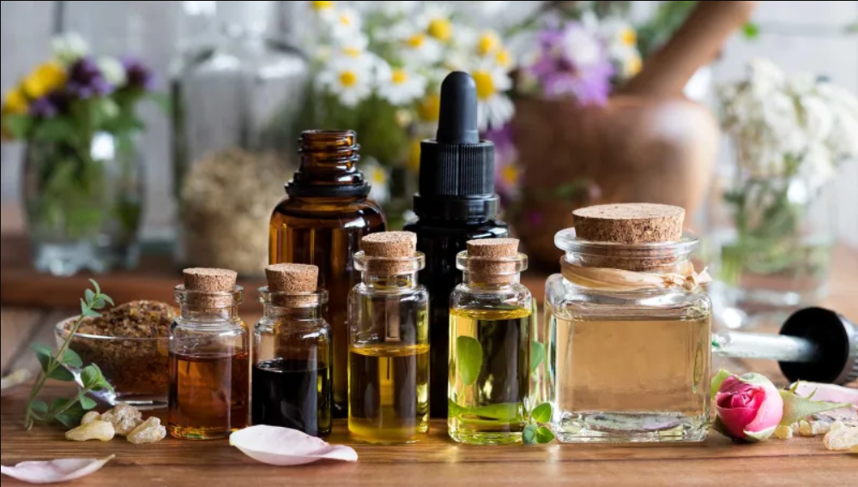
I’ll be honest, I am an ardent fan of cosmetics. One may argue but the truth is that cosmetics have this ability to make you look stunning and enhance your overall appeal. Despite being an ardent cosmetics fan, I would still say that one should keep them to a minimum and that for the obvious reasons. First off, they are expensive and can certainly take a toll on your budget. Secondly, cosmetics do bring a lot of side effects.
In order for you look gorgeous with minimal makeup on, you must have healthy and glowing skin. Fortunately, the road to beautiful skin isn’t as long as you believe. You just need to turn to mother nature and include the following natural oils in your daily skincare regime.

- Argan Oil
Argan oil is often referred to as “Holy Grail” by many skin specialists. Owing to its incredible skin healing properties, argan oil is also included in many skin care cosmetic products. The natural oil is loaded with potent nutrients such as tocopherol, linoleic acids, and antioxidants. Argan oil is wholesome and provides your skin with everything that it needs.
Argan oil is helpful in following skin conditions,
- Acne and bumps – The powerful anti-oxidant suppress acne growth
- Argan oil is also good in suppressing signs of aging
- Affective in treating cuticles, dead cells, and also stimulates hair growth
How to apply Argan Oil:
You can apply argan oil directly to your face or you can also dilute it by adding a few drops of water. The best is to apply a few drops on your face just before you go to bed. If you start to experience results, you can also use argan oil as a moisturizer. Massage 2-3 drops of oil with gentle fingers and let your skin absorb the oil. After some time, wipe off the excess oil with clean towel.

- Lavender Essential Oil:
A lot of ladies do not know much about lavender oil. Lavender oil is a powerful natural oil that is obtained from the seeds and leaves of lavender plant. The oil is rich in minerals and has immense anti-inflammatory properties. Lavender essential oil is widely used and is highly recommended by skin experts. Owing to the benefits it offers for skin, the oil is often referred to as superfood for our skin. Though lavender oil offers innumerable benefits for our skin but what makes lavender oil unique is its fresh aroma that helps you relax.
Here are some top of the line benefits of Lavender essential oil
- Prevents acne and stimulates recovery by fighting bacteria
- The freshness helps in soothing eczema
- Suppresses face wrinkles
How To Use Lavender Essential Oil?
Lavender essential oil can be added in your daily skincare regime in multiple ways. You can reap its benefits by including it in your food and diet or you can also apply it directly on your face and skin. One can also try aroma therapy by breathing the oil through the nose. If you want to get rid of wrinkles and dry skin, apply the oil on your skin with clean fingers before going to bed every night.

- Coconut Oil
Well that no brainer. Coconut oil is the undisputed king of all beauty products be it natural or cosmetic. Coconut is a beauty multi-tasker and offers a myriad of benefits for our skin. Though all coconut oils are powerful beauty boosters but I would particularly recommend Pure Virgin coconut oil as it is extremely rich in Vitamin E, healthy fats and fatty acids.
Coconut oil is a magical potion for skin and here are the reasons why,
- Boosts your skin health and keep it soft and supple in rough weather conditions
- Fights acne and protects skin against all kinds of infection
- Fights bacteria and suppresses the signs of aging.
How To use:
First, wash your face with lukewarm water and then apply 1 teaspoon of pure virgin coconut oil on dry face. In order to reap maximum benefits, apply the oil before going to bed and let your skin absorb the maximum oil. It is wise to consult a specialist first if you want to use coconut oil for acne.

- Black Seed Oil
Often regarded as the “Fountain of youth” black seed oil is arguably one of the most potent skin oils out there. black seed oil has been endorsed by celebrities for its enormous skin benefits. The natural oil is rich in antioxidants and is also a natural disinfectant and brings innumerable benefits for our skin.
Here are some top of the line benefits of black seed oil for skin.
- Guards your skin against all kinds of infection
- keep your skin radiant and moisturized
- Effectively fills fine lines and wrinkles
You can consume black seed oil orally and you might know it already that it is an integral part of several middle-eastern cuisines. For maximum skin benefits, apply the oil on your skin by diluting it with warm water. Gently apply the oil on your face and use a light warm towel to wipe off the access oil.

- Olive Oil
Olive oil is a potent natural oil that is so beneficial for our health and our overall wellbeing that it is often regarded as “Liquid Gold”. The use of olive oil as a cure is not a new discovery and the oil has long been used as a remedy for several chronic diseases and enjoyed a special status in Greek mythology and Abrahamic religions.
When applied on the skin, olive oil offers following benefits,
- Diminishes the signs of aging
- Stimulates exfoliation
- Protects skin in dry weather.
How to use Olive Oil for Skin:
Olive oil is the best remedy for all those who are struggling with dry skin issues. Buy a small bottle of olive oil and apply teaspoon of the oil on your skin. Massage the oil on your skin with gentle fingers before going to bed and let your skin absorb the maximum oil.
The above mentioned 5 natural beauty oils can be a perfect addition to your daily skincare routine. If you are missing out on any of these, it’s never too late. As the Chinese proverb says, “The best time to plant a tree was 20 years ago. The second-best time is now.”

Author Bio:
Martin Taylor is the head writer over Nature’s Blends, an organic products brand based in the UK. Martin is health freak and likes reading and writing about alternative medicines.

